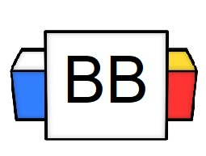 | Question: What are you most dependent on?  Answer:
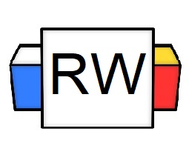 | Directions: Underline any red words that appear in the video. Fill in the blanks with whatever appears in the white text when sentences are corrected. These are keywords and concepts.  Dependent Clause  A dependent clause is NOT capable of standing alone; it depends upon the remainder of the sentence for its meaning. Dependent Clauses make incomplete ideas.  A dependent clause may contain a subject and a verb, but it begins a thought that it doesn't finish.  Examples 1 and 2  - Because Amy left the iron on  - When the firemen arrived at the dorm  Justification: Due to the word “Because” and “When”, these clauses are incomplete. If a clause contains a subordinating conjunction, then it becomes a dependent clause.  Subordinating Conjunctions  Dependent clauses usually start with a subordinate conjunction.  Quick examples of subordinating conjunctions: after, although, as, because, even though, until, when, while, so that  What is a subordinating conjunction?  The purpose of the subordinating conjunctions is to indicate the relationship between the dependent clause (also known as the subordinate clause) to the independent clause.  Example: If we make this sale, we can own a spider monkey.  Note: If you put a subordinating conjunction in front of an independent clause, it will automatically make it a dependent clause.  Example:  He is cool.=Independent Clause  Because he is cool=Dependent Clause  Example:  While he was sitting in the corner, he made friends with a taciturn mouse.  Let’s break this down, and think about this sentence as two independent clauses (there are no suborinating conjunctions in them).  Independent Clause 1: He was sitting in the corner.  Independent Clause 2: He made friends with a taciturn mouse.  Potential Sentence: He was sitting in the corner, he made friends with a taciturn mouse.  Note: The sentence above is not correct, for a lone comma cannot join two independent clauses. One can add a subordinating conjunction to make one of the clauses into a dependent clause. That way, it can create a clear relationship between the two clauses.
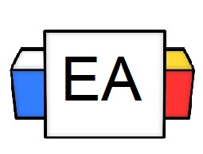 | Directions: Circle the subordinating conjunctions and underline the dependent clauses.  Examples:  - Wherever you go, I will wait for you!  - When Santa Claus woke up in a bathtub full of ice, he could not remember the night before.  - While giving a Snow Yeti a back wax, I realized that I am allergic to fur.  - While his kids were at school, he played in a ping-pong league.  Reverse Example: He played in a ping-pong league while his kids were at school.
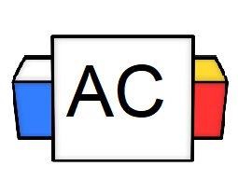 | Directions: Answer the following question in complete sentences.  Question: Why are subordinating conjunctions important?
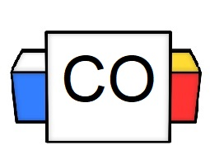 | Final Answer:
Extra Notes | More examples of subordinating conjunctions:  after  although  as (as if)  because  before  even though  if  in order that  rather than  since  so that  than  that  though  unless  until  when  whenever  whereas  whether  while

