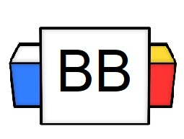 | Question: Why are transition words and phrases important?  Answer:
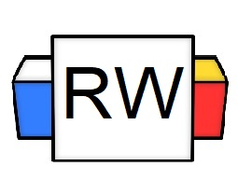 | Directions: Underline any red words that appear in the video.  What is a conjunction?  The conjunction is a part of speech that joins words, phrases, or clauses together.  What is a conjunctive adverb?  A conjunctive adverb is a word (or short phrase) that provides a link to the previous sentence or previous independent clause; basically, it shows the relationship between two complete thoughts.  T.H.A.M.O.S.  Tip: To remember the most basic conjunctive adverbs, one can use the acronym T.H.A.M.O.S. In a sense, think of it like the F.A.N.B.O.Y.S. of conjunctive adverbs.  Letter Word Synonyms/Meaning  T  H  A  M  O  S  Arrangements and Sentence Formulas  One can arrange a sentence in various ways based on the conjunctive adverb's placement.  Sentence Formula Key  IDC Independent Clause  DC Dependent Clause  Conjun. Adv. Conjunctive Adverb
Sentence Formula 1: Compound Sentences and Semicolons

- Quick Note: A semicolon joins two independent clauses that are similar in content/ideas. This arrangement helps create a compound sentence.
- If a writer wants to transition after a semicolon to build clarity about the relationship between two independent clauses, a writer can use a conjunctive adverb and a comma after a semicolon to enhance the flow and clarity.

Independent Clause 1 | ; | Conjun. Adv. | , | Independent Clause 2
I am terrified of dolphins | ; | therefore | , | I do not swim in the ocean.

Note: After the conjunctive adverb, place a comma to offset it from the rest of the sentence/clause.

Quick Note: After the semicolon, you DO NOT have to capitalize the conjunctive adverb.

Sentence Formula 2: Starting a Sentence
If a writer wants to start a sentence with a conjunctive adverb to build off the previous sentence, they can use a conjunctive adverb and a comma to transition into the next sentence/clause.

Quick Note: A sentence can start with a conjunctive adverb. If it does, make sure to capitalize the conjunctive adverb and place a comma behind it to separate it from the independent clause.
Example 1
IDC 1 | . | Conjun. Adv. | , | IDC 2
I am terrified of dolphins | . | Therefore | , | I do not swim in the ocean.

Sentence Formula 3: Ending a Sentence
Watch the extended version of this episode on www.mrgoodiegrammar.com to view this structure

Sentence Formula 4: Interrupting with Parenthetical Commas
If a writer wants to add a conjunctive adverb into the middle of a sentence or clause, they can use parenthetical commas (double commas) to interrupt the thought.
IDC 1 | . | IDC 2 | , | Conjun Adv. | , | IDC 2
I will never swim in the ocean | . | I | , | however | , | think the ocean is incredibly interesting.

Note: As noted, we took the same independent clauses. All we did was change the arrangement, yet the sentence’s meaning stays the same.
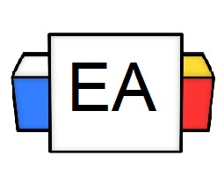 | Directions: Read each sentence carefully. Then add in any commas/semicolons that properly punctuate the sentence. If the sentence is already correctly punctuated, then DO NOT change it.  Sentence 1: The crows were not afraid of the scarecrow; therefore, they easily ate the farmer’s crops.  Sentence 2: Jared has awful breath; also he eats way too much candy.  Sentence 4: Timmy’s parents do not let him eat pasta; however, he secretly eats it at 3:00 A.M.
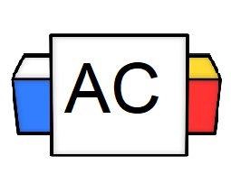 | Directions: Read the following passage, and add the correct punctuation.  Passage  My name is Randal however my friends call me Randy. The interesting thing about me is that I am a lawyer and I love to practice law. I like to argue for those that do not have a voice meanwhile many other lawyers try to silence voices. I find that to be frustrating therefore I make it my mission to work even harder to speak up for my clients. Otherwise I am unsure who will speak up for them.
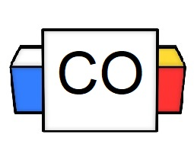 | Your Answer: (see above)
Extra Notes

