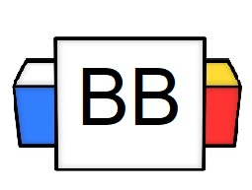 | Question: How do you express your emotions?  Answer:
Directions: Underline any red words that appear in the video. Fill in the blanks with whatever appears in the white text when sentences are corrected. These are keywords and concepts.

What does exclamatory mean?

As defined, exclamatory is an adjective that means, “relating to a sudden cry or remark, especially one expressing surprise, anger, or pain.”

What is an exclamatory sentence?
An exclamatory sentence expresses intense emotions.
It ends in an exclamation point.

Example 1: Vacuums will take over the world!

Example 2: My retinas are searing with pain!

Example 3: I won the Chili Cook Off!

Directions:
- In the next section, you will be given different sentences. Read each sentence and determine if it’s an example of an exclamatory sentence.
- Check the box for either “yes” or “no” to confirm your answer.
- Explain WHY you believe it to be an exclamatory sentence.

Sentence 1: How did my car hide the fact that it is a Transformer?

Is this an example of an exclamatory sentence?

Yes No

Why do you believe that your answer is correct?

Sentence 2: I cannot believe that you would destroy my Oreo garden!

Is this an example of an exclamatory sentence?

Yes No

Why do you believe that your answer is correct?

Sentence 3: I buried my half-eaten lollipop.

Is this an example of an exclamatory sentence?
Yes No

Why do you believe that your answer is correct?

Sentence 4: Why would the Kool-Aid Man do that!

Is this an example of an exclamatory sentence?

Yes No

Why do you believe that your answer is correct?

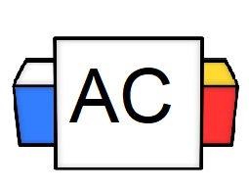 | Directions: Write two original examples of an exclamatory sentence.  Brainstorming Area:
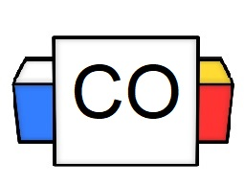 | Your Answers:  Sentence 1:  Sentence 2:
Extra Notes

