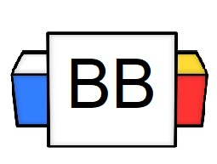 | Question 1: What is your favorite punctuation mark?  Answer:
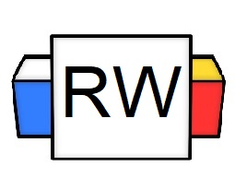 | Directions: Underline any red words that appear in the video. Fill in the blanks with whatever appears in the white text when sentences are corrected. These are keywords and concepts.  Review  Question: What is a sentence?  A sentence is a group of words expressing a complete thought.  Complete sentences are made up of two items:  - Subject  - Predicate  Example: General Grammar has the coolest episodes.  Types of Sentences  There are 4 types of sentences:  - Declarative  - Interrogative  - Imperative  - Exclamatory  There are only 3 punctuation marks with which to end a sentence.  - Period.  - Question Mark?  - Exclamation Point!  Declarative Sentence  - A declarative sentence expresses an opinion or makes a statement. It makes a declaration.  - It ends in a period.  Example: That squirrel is following me.  Example: He swam with megalodon sharks.  Interrogative Sentence  - An interrogative sentence asks a question.  - This type of sentence often begins with who, what, where, when, why, how, or do  - It ends in a question mark.  Example: Who sent you? Who do you work for?  Example: Why do I always burn the pizza?  Imperative Sentence  - An imperative sentence makes a request or demand.  - It usually ends in a period; however, it can end in an exclamation point (under certain circumstances).  Example:  - You need to leave me alone.  - You need to leave me alone!  Example:  - Please take the train.  - Take the train and get out of here!  Exclamatory Sentence  - An exclamatory sentence expresses intense emotions.  - It ends in an exclamation point.  Example: He is trying to overthrow me!  Example: My life is descending into the dark abyss of the sea!
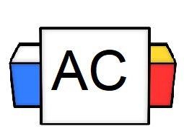 | Directions: For this section, write an original sentence for each of the sentence types and post them into the comment  - Declarative  - Imperative  - Interrogative  - Exclamatory  Brainstorming Area:
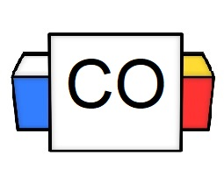 | Your Answers:  Declarative:  Imperative:  Interrogative:  Exclamatory:
Extra Notes

