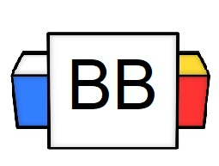 | Question: How would you describe the current state of your bedroom?  Answer:
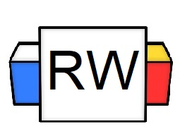 | Directions: Underline any maroon words that appear in the video. These are keywords and concepts.  Adjective: This part of a speech is used to describe a noun or a pronoun.  Adjectives can specify the quality, the size, and the number of nouns or pronouns.  Question: Why are adjectives important?  Answer: Adjectives are important because they give more specificity and detail about nouns or pronouns. Adjectives are used to paint a picture in the reader’s mind.  Directions: Underline the adjectives in the list and sentences below.  - Brave soldier  - Bright lights  - Famous Youtube influencer  - Unhinged mother  - Smelly socks  - Deranged witch  Example: That doughnut is huge!  Example: I have two hamsters.
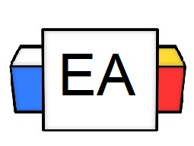 | Directions: Underline the adjectives in the sentences below.  Example: I have the worst service.  Example: I can hear the constant singing of deranged, invisible birds chirping in my brain.
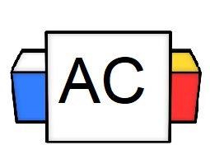 | Directions: Write as many adjectives as you can in 30 seconds.
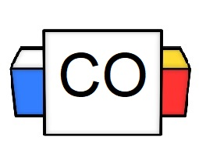 | Directions: Count up the total number of adjectives that you wrote.  Question: How many did you write?  Question: What were your favorite three adjectives?
Extra Notes

