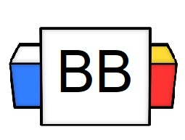 | Question: Who were married on April 4th, 2008?  Answer:
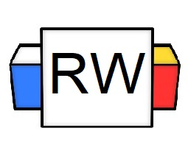 | Reminder: The first sentence structure that we discussed was a simple sentence.  A simple sentence is made up of 1 independent clause (IDC).  Compound Sentence  A compound sentence joins 2 independent clauses together to form one sentence.  Compound sentences can be made in a variety of ways.  Compound Sentence Structure 1:  One of the most common ways of combining 2 independent clauses together is by using a comma and a coordinating conjunction (FANBOYS).  F.A.N.B.O.Y.S. is an acronym that is used to remember the 7 basic coordinating conjunctions.  Directions: Fill in the conjunction after each letter.  F  A  N  B  O  Y  S  Compound Sentence Formula 1:  1 independent clause + , + FANBOYS + 1 independent clause  (1 IDC) + (,) + (FANBOYS) + (1 IDC)  Example Breakdown:  Independent clause 1: My life is a mess.  Independent clause 2: No one can control me.  Combined to form a compound sentence.  My life is a mess, and no one can control me.  (1 IDC) + (,) +(FANBOYS) + (1 IDC)  Important Note:  You need to place the comma BEFORE the coordinating conjunction when joining the two independent clauses.  Incorrect example: My life is out of control and, I really need to handle it.  Correct example: My life is out of control, and I really need to handle it.  Example:  Sloths are lazy, yet they somehow survive.  ( 1IDC) + (,) + (FANBOYS) + (1 IDC)  Important Note 2:  It would be best to have both a comma and a FANBOYS to make a compound sentence. Either or on its own is not strong enough to bring the 2 independent clauses together.  Example:  The witch in Hansel and Gretel didn’t want to go hungry, so she devoured children instead.
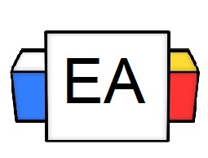 | Directions: For this section, underline the independent clauses and circle the comma and FANBOYS in each sentence.  Example 1:  She didn’t get a Porsche for her twelfth birthday, so she sued her parents.  Example 2:  My hairline looks like it was attacked by a ravenous hyena, so I just wear hats.  Example 3:  The water is boiling, but there is nothing in the pot.
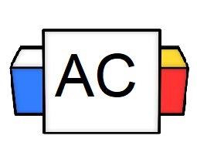 | Directions: For this Aisle Check, you will create an original compound sentence that is joined together by a comma and a FANBOYS.  Brainstorm area:
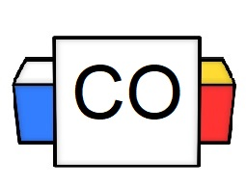 | Final Sentence:
Extra Notes

