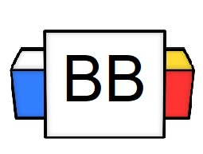 | Question: On average, how many diapers does a baby use in his/her first year of existence?  Answer:
Directions: Underline any red words that appear in the video. Fill in the blanks with whatever appears in the white text when sentences are corrected. These are keywords and concepts.

Reminder:
A dependent clause is a clause that has a subject and a verb but doesn’t make sense on its own.
It is usually started by a subordinating conjunction.

Dependent Clause Examples:
- Once I decide to actually listen
- Since he was very superficial
- After my grandmother decided to morph into a dusty tortoise

Complex Sentence
A complex sentence is one sentence that consists of one independent clause and one or more dependent clauses.

Complex Sentence Creation
Example 1:
Dependent Clause:
After my grandmother decided to morph into a dusty tortoise

Independent Clause:
I decided to feed her lettuce.

Final Complex Sentence:
After my grandmother decided to morph into a dusty tortoise, I decided to feed her lettuce.

Example 2:
Dependent Clause:
Once I decided to actually listen

Independent Clause:
I had an epiphany that he is a lizard person.

Final Complex Sentence:
Once I decided to actually listen, I had an epiphany that he is actually a lizard person.

Complex Sentence Formula 1
1DC + ,+ 1 IDC
- DC=Dependent Clause
- IDC= Independent Clause

Note: A subordinate/dependent clause that opens the sentence is always set off by a comma.

Note: This rule applies no matter how short the clause may be.

Example 3:
While you were sleeping, the tooth fairy robbed your piggy bank

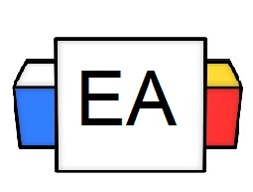 | Directions: You will be provided with an independent clause. It is your job to add a dependent clause before it in order to make a complex sentence.  .  Practice Example:  Independent Clause: The rabbit was late.  Complex Sentence: Because of the horrible gardening incident, the rabbit was late.  List of some subordinating conjunctions that you can use to form dependent clauses:  - After  - Because  - Although  - When  - While  - Since  - Once  Question 1:  Independent Clause: The Amazon package arrived.  Your Example:  Question 2:  Independent Clause: Walt Disney has a captivating life story.  Your Example:  Question 3:  Independent Clause: His business will crumble  Your Example:
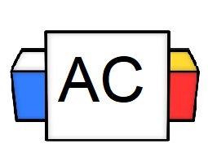 | Directions: Write 3 original complex sentences that begin with dependent clauses.  Remember: 1 DC + (,) + 1 IDC  Brainstorming Area
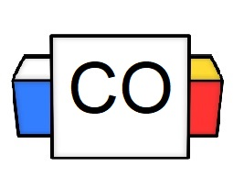 | Final Answers:  1.  2.  3.
Extra Notes | More examples of subordinating conjunctions:  after  although  as (as if)  because  before  even though  if  in order that  rather than  since  so that  than  that  though  unless  until  when  whenever  whereas  whether  while

