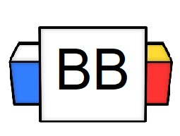 | Question: What are some of the most iconic catchphrases from the cartoon Scooby-Doo?  Answer(s):
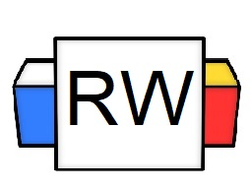 | Directions: Underline any maroon words that appear in the episode. These are keywords and concepts.  Interjection: This part of a speech refers to words that express emotions, and they are usually followed by an exclamation point.  Example: It's time for me to go. Cheerio!  Example: Yowza! That is a gorgeous mullet!  Examples:  - Ughhh!  - Brrr!  - Phew! Sorry!  - Whoops!
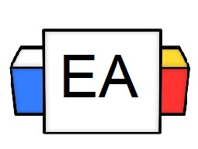 | Directions: Underline the interjection(s) in each sentence.  Example: Holy cow! That cow is praying!  Example: Hush! I can’t take this heartbreak anymore.  Example: Oh my! The succubus has been defeated. Lo and behold! I am the eternal king.
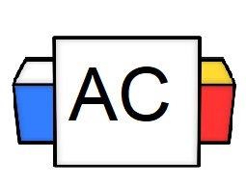 | Directions: Write as many interjections as you can in 30 seconds.
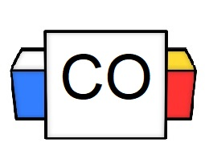 | Directions: Directions: Count up the total number of interjections that you wrote.  Question: How many did you write?  Question: What were your favorite three interjections?
Extra Notes

