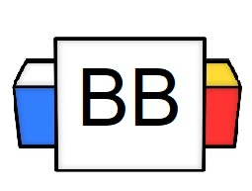 | Question: In the Marvel Universe, who is the smallest superhero?  Answer:
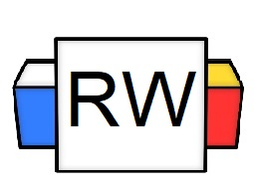 | Directions: Underline any maroon words that appear in the video. Fill in the blanks with whatever appears in the white text when sentences are corrected. These are keywords and concepts.  Simple Sentence  A simple sentence is the most basic sentence one can compose. It consists of a subject and a predicate (1 independent clause).  Example: The vivacious velociraptor performed a tap dance.  Note: “Vivacious” is an example of a Word of the Week.  Simple Sentence Formula  Simple Sentence=1 Independent Clause (1 IDC)  Example: I went absolutely crazy during the quarantine.  Example: Underwater basket weaving is a high octane sport!  Why are simple sentences important?  Not only do simple sentences act as the foundation for sentence structures, but they also have strong rhetorical effects.  By using a simple sentence, it makes the information concise and direct, while also adding emphasis.  The first sentence from the novel The Stranger by Albert Camus is a profound and simple sentence: “Mother died today.”  It creates an intense emphasis that drew the reader’s eye right to the sentence.
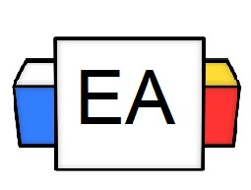 | Directions: For each given sentence, determine whether or not it is an example of a simple sentence.  Ask yourself the following questions:  - Does it have a subject?  - Does it have a predicate?  - Does it make complete sense by itself?  - Is it one independent clause?  Example: The bandit stole the ice cream from the baby.  Is this an example of a simple sentence? Yes_______ No_________  Example: My esophagus feels like it has processed glass.  Is this an example of a simple sentence? Yes_______ No_________  Example: The sloth mistook its arm for a branch and fell to its death.  Is this an example of a simple sentence? Yes_______ No_________
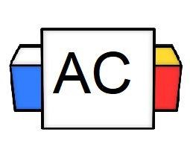 | Directions: For this, Aisle Check, you will create an original simple sentence. It can be about anything, but it needs to have all the elements of a simple sentence.  Brainstorming Area
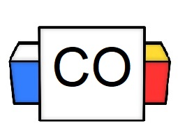 | Directions: Put your final answer to the Aisle Check.  Answer:

