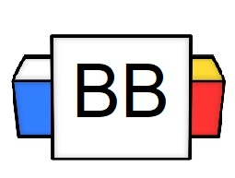 | Question: What are some of the most self-sufficient and independent animals on the globe?  Answers:
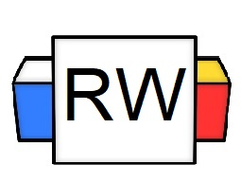 | Directions: Underline any maroon words that appear in the video. Fill in the blanks with whatever appears in the white text when sentences are corrected. These are keywords and concepts.  Clause  Clause: a group of words that has both a subject and a predicate.  There are two types of clauses:  - Dependent  - Independent  Independent Clause  An independent clause is a group of words with at least one subject and one verb that can make complete sense by itself.  Example: He ripped the crocodile’s mouth open with his bare hands.  Example: He tripped.  Example: The creature hunts for food by the lagoon.
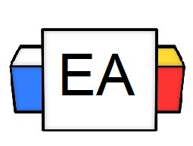 | Directions: For each given sentence, determine whether or not it is an example of an independent clause.  Ask yourself the following questions:  - Does it have a subject?  - Does it have a verb?  - Does it make complete sense all by itself?  Example: A Rubik’s Cube is the embodiment of our own emotional complexities.  Is this an example of an independent clause? Yes_______ No_________  Example: I am addicted to drinking Red Bull.  Is this an example of an independent clause? Yes_______ No_________  Example: I left my kidney in an ice-filled bathtub.  Is this an example of an independent clause? Yes_______ No_________
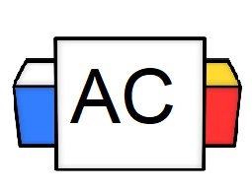 | Directions: For this, Aisle Check, you will create an original independent clause. It can be about anything, but it needs to have all the elements of an independent clause.  Brainstorming Area
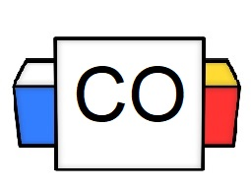 | Directions: Put your final answer to the Aisle Check.  Answer:

