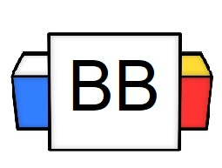 | Question: In the movie Austin Powers, why did Dr. Evil create his clone, Mini-Me?  Answer:
Directions: Underline any maroon words that appear in the video. These are keywords and concepts.

Pronouns are shorter words that stand in for nouns.

Some examples of pronouns: I, it, me, my, his, hers, theirs, ours, they, we

Question: Why do we use pronouns?

Answer: We use pronouns so that we do not have to constantly repeat the noun over and over.

Original: Brian is my best friend. Last year, Brian won the lottery, and Brian received over $145 million. Now, Brian does not talk to me and has rich friends.

What wrong with the example above?

Answer:

Rewritten: Brian is my best friend. Last year, he won the lottery and received over $145 million. Now, he does not talk to me and has rich friends.

Establish your subject with a clear noun first, for this creates context.

Afterward, you can use pronouns to replace the subject.

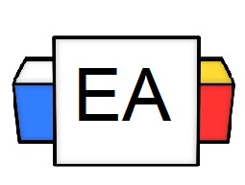 | Directions: Underline any pronoun(s) that appears in a sentence.  Example: My father is a costly lawyer, but he argues with me for free.  Example: My family thinks I am the black sheep because I like to urinate in bottles and store them.  Example: I don't want you to regret it.  Keep in mind, when writing, you need to make sure that your pronoun has a clear antecedent, which means the noun that it took over for.  Your reader needs to know the “who" or "what” the pronoun refers to make sense.
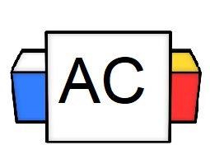 | Directions: Underline the pronoun(s) in the given sentence.  Question: My mom threatened to take away my Xbox, so I planted bear traps around my room to get her.
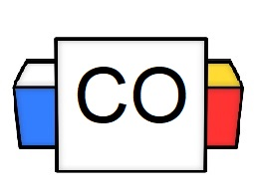 | Question: What did you underline?  Answer:
Extra Notes

