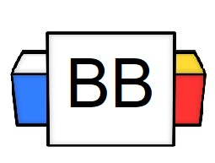 | Question: How would you describe your most prized possession?  Answer:
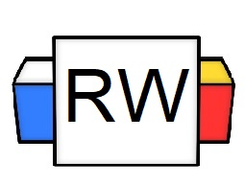 | Directions: Underline any maroon words that appear in the episode. These are keywords and concepts.  Adverbs: Just like adjectives, adverbs are also used to describe words, but the difference is that adverbs describe adjectives, verbs, or another adverb.  There are different types of adverbs, depending on the circumstance and other words being modified.  - Adverbs of Manner  - Adverbs of Time  - Adverbs of Place  - Adverbs of Degree  - Adverb of Manner: This refers to how something happens or how an action is done.  Example: Tiffany danced gracefully.  - Adverb of Degree: This states the intensity or the degree to which a specific thing happens or is done.  Common Examples: really, so, too, slightly, hardly  Example: That man is extremely attractive.  - Adverb of Time: This states “when” something happens or “when” it is done.  Example: The mail came yesterday.  - Adverb of Place: This tells something about “where” something happens or ”where” something is done.  Example: Of course, I looked everywhere!
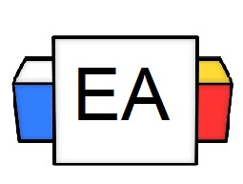 | Directions: Find and underline the adverb(s) in each sentence.  Example: My cat is constantly plotting my demise.  Note: With many adverbs, they usually end in “ly.”  Example: The seemingly bashful llama spat on my fraternity brother’s face.  Example: His alligator is very calm.
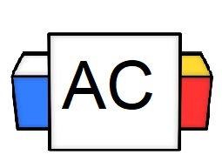 | Directions: Underline the adverbs in the given sentence.  Question: Pennywise the Dancing Clown viciously stalks his very innocent victims.
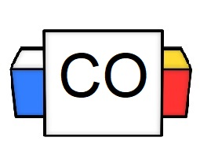 | Question: What words did you underline?  Answer:
Extra Notes

