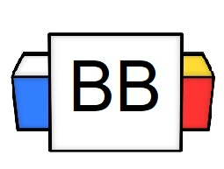 | Question: What is your favorite quote?  Answer:
Directions: Underline any red words that appear in the video. Fill in the blanks with whatever appears in the white text when sentences are corrected. These are keywords and concepts.

Review

Types of Sentences
There are 4 types of sentences:
- Declarative
- Interrogative
- Imperative
- Exclamatory

There are only 3 punctuation marks with which to end a sentence.
- Period.
- Question Mark?
- Exclamation Point!

Declarative Sentence
- A declarative sentence expresses an opinion or makes a statement. It makes a declaration.
- It ends in a period.

Example: I want to climb that cactus, so I can write poetry.
Note: This makes a statement.

Example: My friends and family are so mean because they told me that my poetry is horrible.
Note: This expresses an opinion.
Example: For Tara’s next vacation, she plans on traveling to Las Vegas.

Example: Brian’s favorite piece of technology is his sentient vacuum cleaner.

Example: Joey loves German Shepards because they are protective.

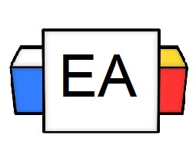 | Directions:  - In the next section, you will be given different sentences. Read each sentence and determine if it’s an example of a declarative sentence.  - Check the box for either “yes” or “no” to confirm your answer.  - Explain WHY you believe it to be a declarative sentence.  Sentence 1: He is slowly strolling across the plank that is above the shark tank.  Is this an example of a declarative Sentence?  Yes No  Why do you believe that your answer is correct?  Sentence 2: Who were you texting?  Is this an example of a declarative Sentence?  Yes No  Why do you believe that your answer is correct?  Sentence 3: I worked for The Pony Express; now, I work for an off-Broadway version of Cats: The Musical.  Is this an example of a declarative Sentence?  Yes No  Why do you believe that your answer is correct?  Sentence 4: I like turtles.  Is this an example of a declarative Sentence?  Yes No  Why do you believe that your answer is correct?
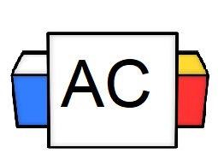 | Directions: Write two original examples of a declarative sentence.  Brainstorming Area:
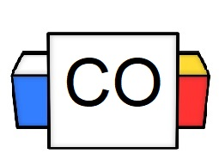 | Your Answers:  Sentence 1:  Sentence 2:
Extra Notes

