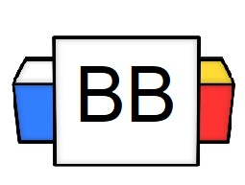 | Question: What makes up a complex sentence?  Answer:  Example: Since we are done with the Basket Breaker, it’s time to drink up some radioactive waste.
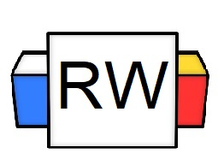 | Directions: Underline any red words that appear in the video. Fill in the blanks with whatever appears in the white text when sentences are corrected. These are keywords and concepts.  Arrangement 1 Formula  Dependent Clause + , + Independent Clause.  DC+ , +1 IDC  Example: Wherever the King stakes his banner, the people begin to praise him.  The next arrangement to make a complex sentence is even more simple. In fact, it might be as simple as flipping your sentence.  Since we know that a complex sentence is made of 1 independent clause and 1 or more dependent clauses, we can order it in various ways.  For this arrangement, we can put our independent clause first followed by the dependent clause.  Arrangement 2 Formula  1 independent Clause + 1 or more Dependent Clauses  1 IDC+1 DC (or more)  Example: Unless Mario focuses on plumbing rather than defeating Bowser, his business will crumble  Flip the structure.  Example: Mario’s business will fail unless he focuses on plumbing rather than defeating Bowser.  Example: He could not open the pickle jar even though he was incredibly muscular.  Note: We can even flip the clauses, and the sentence often carries the same meaning.  Example: Even though he was incredibly muscular, he could not open the pickle jar.  Commas and Complex Sentences  - If you start a complex sentence with a dependent clause, you need a comma to separate it from the independent clause.  - However, if you start a complex sentence with an independent clause, you do not normally need a comma to separate them.  Example: I can go camping as long as there are no demonic beasts frolicking through the woods.  Example: The Gingerbread Man’s home will be quickly devoured by ravenous children if he relocates to Candyland.
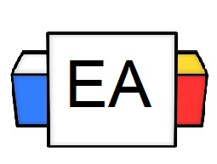 | Directions: For this section, I am going to read various complex sentences aloud. Together, we will do the following.  - Underline the independent clause  - Square the dependent clause  - Circle the subordinating conjunction (the word(s) that usually start the dependent clause).  Example 1: I thought I was going to get some rest until the lawnmowers started outside my window.  Example 2: My summer romance ended when he ghosted me to go cave diving.  Example 3: Brenda is going to get a reality check if she continues to gossip by the water cooler.
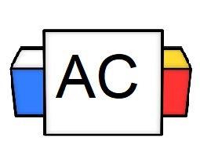 | Directions: For this section, write an original complex sentence that begins with an independent clause  Brainstorming Area:
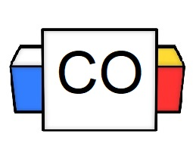 | Example Answer: Humans shall cease to be the pinnacle of evolution once neuro-superior dolphins take control of the troposphere.  Your Answer:
Extra Notes

