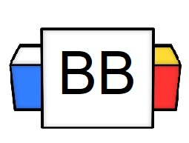 | Question: What was Vlad the Impaler’s favorite activity?  Answer:
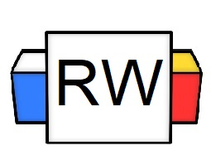 | Directions: Underline any maroon words that appear in the video. These are keywords and concepts.  Verb: This is the most important part of a speech, for, without a verb, a sentence would not exist.  As defined, a verb shows an action (physical or mental) or state of being of the subject in a sentence.  Action Verbs:  - Run  - Hide  - Jump  - Fight  - Swim  Remember: Verbs also represent a state of being.  State of Being Examples:  - Is  - Are  - Am  - Was  - Were  Note: Verbs almost always come after the noun or pronoun in a sentence.  Example: As usual, the Stormtroopers missed their shot.  Example: They are always prepared in emergencies.
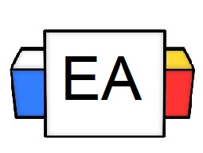 | Directions: Underline the verb(s) in each sentence.  Example: The velociraptor performed a tap dance.  Example: The zombies stole and ate my brain.
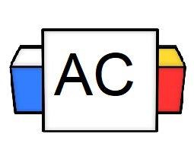 | Directions: Write as many verbs as you can in 30 seconds.
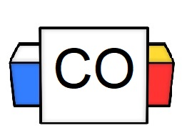 | Directions: Count up the total number of verbs that you wrote.  Question: How many did you write?  Question: What were your favorite three verbs?

