Question 1: What is a compound sentence?

Answer:

Question 2: What’s a dependent clause?

Answer:

Directions: Underline any red words that appear in the video. Fill in the blanks with whatever appears in the white text when sentences are corrected. These are keywords and concepts.

Compound-Complex Sentences

A compound-complex sentence is composed of 2 independent clauses and one or more dependent clauses. In another way, think of it as adding dependent clauses to a compound sentence.

Directions: For the upcoming examples, we will create a compound sentence first, and then we shall add a dependent clause to it.

Example 1
Independent Clause 1: My cat could rule the world.
Independent Clause 2: She is too lazy.
Compound: My cat could rule the world, but she is too lazy.
Add a dependent clause.
Dependent Clause 1: Because she is super intelligent.
Final Compound-Complex Sentence: Because she is super intelligent, my cat could rule the world, but she is too lazy.

Here are examples of complete compound-complex sentences.

Example 2
When it is foggy, it is hard to see the road, so I do not recommend driving.
Example 3
Even though he is herding cats in space, he still has a fear of heights, and I do not understand how he does it!

Directions: For this section, I am going to read various complex sentences aloud. Together, we will do the following.
- Underline the independent clauses
- Square the dependent clause(s)
- Circle the subordinating conjunction(s)

Example 1
Since Superman started attending therapy, he seems more upbeat, and he doesn’t blast random civilians with laserbeams.

Example 2
Despite the fact that a T-Rex stole my iPhone, I still went out for the Fourth of July, but I ended up chipping my teeth.

Example 3
When Ash threw a Pokeball at Jigglypuff, it immediately bounced off the Pokemon, and the Jigglypuff sang him to sleep and drew all over his face.
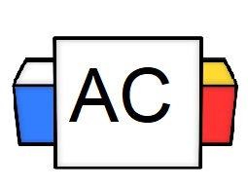 | Directions: For this section, write an original compound-complex sentence (in any arrangement).  Brainstorming Area:
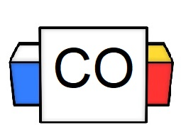 | Example Answer: Before your girlfriend breaks up with you, you need to buy her flowers, and you must beg for forgiveness.  Your Answer:
Extra Notes

