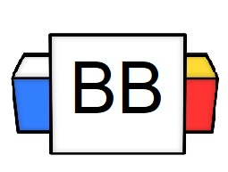 | Question: What is the strangest question that someone has ever asked you?  Answer:
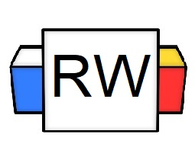 | Directions: Underline any red words that appear in the video. Fill in the blanks with whatever appears in the white text when sentences are corrected. These are keywords and concepts.  Interrogative Sentence  As defined, interrogative is an adjective that means, “having or conveying the force of a question.”  An interrogative sentence asks a question.  - This type of sentence often begins with who, what, where, when, why, how, or do  - It ends in a question mark.  Example 1: How many times do I have to tell you to put your jester hat away?  Example 2: Did the cat win the fencing match?  Example 3: Did you ever have a huge rival?  Fun Note: Some writers will use both a question mark and exclamation point for an exclamatory question, but only the exclamation point is truly necessary.  Example 4: Why won’t you leave me alone?  Example 5: Why won’t you leave me alone!
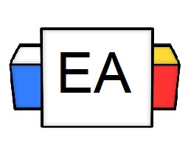 | Directions:  - In the next section, you will be given different sentences. Read each sentence and determine if it’s an example of an interrogative sentence.  - Check the box for either “yes” or “no” to confirm your answer.  - Explain WHY you believe it to be an interrogative sentence.  Sentence 1: What’s your biggest fear?  Is this an example of an interrogative sentence?  Yes No  Why do you believe that your answer is correct?  Sentence 2: My car exploded into a fiery inferno.  Is this an example of an interrogative sentence?  Yes No  Why do you believe that your answer is correct?  Sentence 3: Sarah is renting an upscale mobile home in Antarctica.  Is this an example of an interrogative sentence?  Yes No  Why do you believe that your answer is correct?  Sentence 4: Since you adopted your sixtieth cat, do you get any sleep?  Is this an example of an interrogative sentence?  Yes No  Why do you believe that your answer is correct?
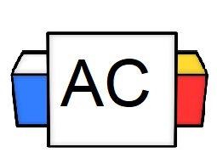 | Directions: Write two original examples of an interrogative sentence.  Brainstorming Area:
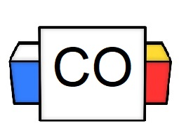 | Your Answers:  Sentence 1:  Sentence 2:

