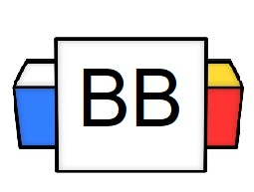 | Question: What is a sentence?  Answer:
Directions: Underline any maroon words that appear in the video. These are keywords and concepts.

Subject

A subject is the “what” of the sentence.
It lets you know what the sentence will be about.

The subject of a sentence is the person, place, thing, or idea (noun) that is doing or being something.

Example:

- Darth Vader sliced off my right hand.

Types of subjects:
- Simple
- Complete
- Compound

Simple Subject
A simple subject is a subject that has just one noun/pronoun as the focus of the sentence.

This means that only one noun/pronoun does the action/connects to the verb of the sentence.

Example:

- Mick decided to start a food fight.

Complete Subject
The complete subject is who or what is doing the verb plus all of the modifiers [descriptive words] that go with it.

Example:

- My crazy life is out of control.

Compound Subject
A compound subject contains two or more simple subjects that have the same verb or verb phrase.

They are usually linked together with the conjunctions: and, or, or nor.

Example:

- Becky and Ryan will call us when they get back from their camping trip to “Never Going to Live Falls.”

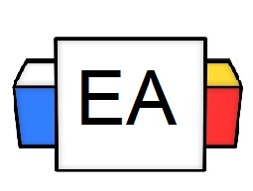 | Directions: In the given sentences below, complete the following tasks.  - Circle the simple subject in each sentence  - Underline the complete subject in each sentence  Examples:  - The insanely talented velociraptor performed a tap dance.  - Ariana Grande’s ponytail saved lives tonight.
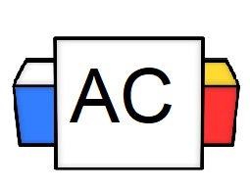 | Directions: In the given sentences below, complete the following tasks.  - Circle the simple subject in each sentence  - Underline the complete subject in each sentence  Sentence: His intense and fiery gaze blasted through the bleakness of the party.
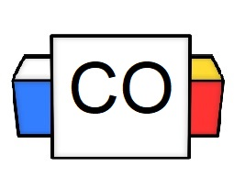 | Answer to Aisle Check:  - Simple Subject:  - Complete Subject:  What questions do you still have about subjects?  Directions: Make sure to go into the comments and attempt to identify the subject in other people’s examples.

