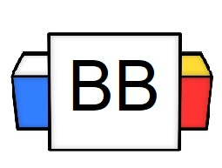 | Question: What makes a complete sentence?  Answer:
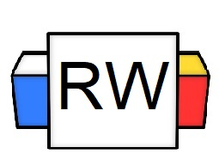 | Directions: Underline any maroon words that appear in the video. These are keywords and concepts.  Predicate  The predicate is the verb that explains what the subject is doing.  Example: Dracula combusted into flames after drinking SunnyD.  Example: Predator stalked Arnold Schwarzenegger through the jungle.  Simple Predicate  The simple predicate is always a verb (word or words that express an action or state of being). It is usually one word.  Example: Mickey Mouse engaged in a gang fight.  Example: Aidan expounded his ideas for a pyramid scheme.  Complete Predicate  A complete predicate includes not only the verb or verb phrase but also all the words that give more information about it.  Example: Dracula combusted into flames after drinking Sunny-D.  Example: Predator stalked Arnold Schwarzenegger through the jungle.
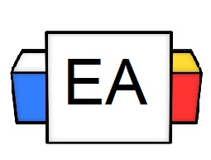 | Directions: In the given sentences below, complete the following tasks.  - Circle the simple predicate in each sentence  - Underline the complete predicate in each sentence  Example: Elon Musk engineered the PowerPuff Girls.  Example: The insanely talented velociraptor performed a tap dance.  Example: Little Tapioca is always yapping up a storm.  Example: My obnoxiously large zit popped puss into the mirror!
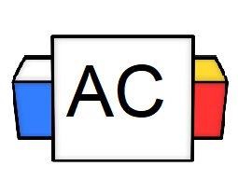 | Directions: In the given sentences below, complete the following tasks.  - Circle the simple predicate in each sentence  - Underline the complete predicate in each sentence  Sentence: My rambunctious dog is so sick of that diabolical squirrel.
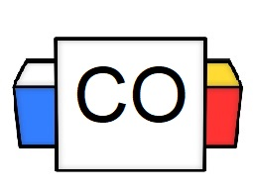 | Answer to Aisle Check:  - Simple Predicate:  - Complete Predicate:  What questions do you still have about predicates?  Directions: Make sure to go into the comments and attempt to identify the predicate in other people’s examples.

