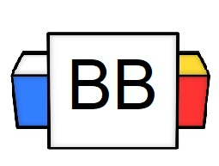 | Question: Which individual has the most followers on Instagram?  Answer:
Directions: Underline any maroon words that appear in the video. These are keywords and concepts.

Noun: A noun is of a speech that refers to words that are used to name persons, things, animals, places, ideas, or events.

Question: What are some examples of nouns shown in the episode?

There are various types of nouns:
- Proper Nouns
- Common Nouns
- Abstract Nouns
- Concrete Nouns

Directions: Underline the noun(s) in each sentence.

Example: The kangaroo threw a boomerang.

Example: Cats are excellent pets.

Example: Psychopaths love drinking milk.

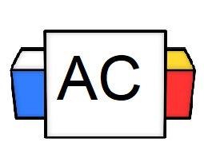 | Directions: Write as many nouns as you can in 30 seconds.
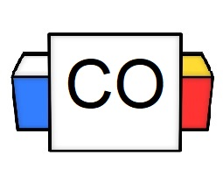 | Directions: Count up the total number of nouns that you wrote.  Question: How many did you write?  Question: What were your favorite three nouns?
Extra Notes

