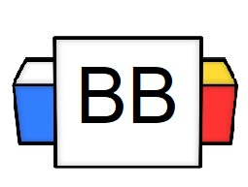 | Question: In the song “Tuesday” by ILoveMakonnen, where’s the club going?  Answer:
Directions: Underline any maroon words that appear in the episode. These are keywords and concepts.

A preposition is a part of speech that refers to words that specify a location or a location in time.

Examples of prepositions: above, below, during, throughout, outside, before, near, and since.

Example: Micah is hiding under the bed.

Example: During the game, the audience never stopped cheering for its home team.

Directions: Underline the preposition(s) in each sentence.

Example: We ran into each other numerous times throughout the apocalyptic war.

Example: I will be on QVC one day!

Example: Hansel was serenaded in a phone booth

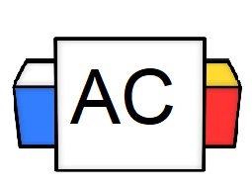 | Directions: Underline the preposition(s) in the given sentence.  Question: During the dinner, he reached across the table and grabbed the butter.
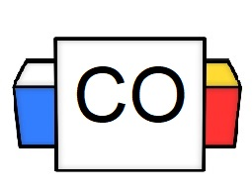 | Question: What words did you underline?  Answer:
Extra Notes

